**Contact Management System**

**Aryan Gawde, FyBscIT, A024, 45207220012**

**Abstract/synopsis:** Using this project, we can easily add, view, edit, search and delete contacts.

We can list contacts by name, phone no., address, and email.

File handling is used to record all data so that after termination of the program data persists.

Here a data structure is used to store the name, email, and contact.

This program is created by using turbo c++

**Keywords:** contacts,details,structures,loops,arrays

**Scope:** The scope of the project is to make it easy to manage contacts of users so the users can find, edit, delete the contacts conveniently.

**SCREENSHOTS:**

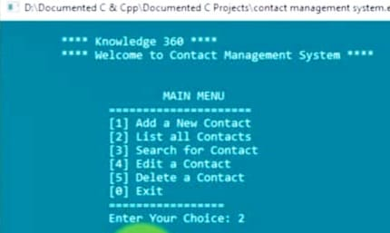

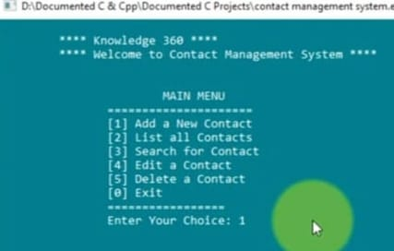

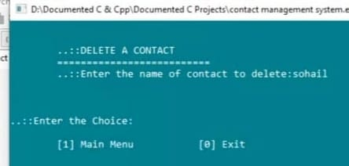

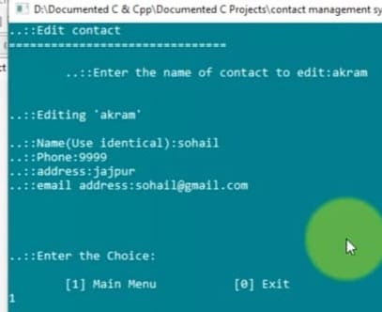

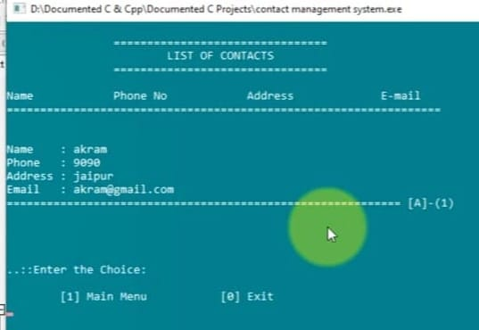

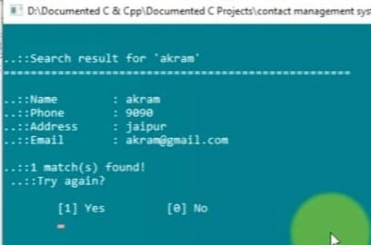

**SOURCE CODE:**

**/*Using this project, we can easily add, view, edit, search and delete contacts.**

**We can list contacts by name, phone no., address, and email.**

**File handling is used to record all data so that after termination of the program data persists.**

**Here a data structure is used to store the name, email, and contact.**

**Coding of the project is short and simple.*/**

**#include<stdio.h>**

**#include<conio.h>**

**#include<string.h>**

**#include<process.h>**

**#include<stdlib.h>**

**#include<dos.h>**

**struct contact**

**{**

**long ph;**

**char name[20],add[20],email[30];**

**} list;**

**char query[20],name[20];**

**FILE *fp, *ft;**

**int i,n,ch,l,found;**

**//Start of main//**

**int main()**

**{**

**main:**

**system("cls"); /* ************Main menu *********************** */**

**system("color 3f");**

**printf("\n\t **** Knowledge 360 ****");**

**printf("\n\t **** Welcome to Contact Management System ****");**

**printf("\n\n\n\t\t\tMAIN MENU\n\t\t=====================\n\t\t[1] Add a New Contact\n\t\t[2] List all Contacts\n\t\t[3] Search for Contact\n\t\t[4] Edit a Contact\n\t\t[5] Delete a Contact\n\t\t[0] Exit\n\t\t=================\n\t\t");**

**printf("Enter Your Choice: ");**

**scanf("%d",&ch);**

**switch(ch)**

**{**

**//This case is used for Exit//**

**case 0:**

**printf("\n\n\t\tAre You Sure To Exit?");**

**break;**

**/* *********************Add new contacts************ */**

**//This case is used for Add a new Contact//**

**case 1:**

**system("cls");**

**fp=fopen("contact.dll","a");**

**for (;;)**

**{**

**fflush(stdin);**

**printf("To Exit Enter Blank Space in the Name Input\nName (Use identical): ");**

**scanf("%[^\n]",&list.name);**

**if(stricmp(list.name,"")==0 || stricmp(list.name," ")==0)**

**break;**

**fflush(stdin);**

**printf("Phone: ");**

**scanf("%ld",&list.ph);**

**fflush(stdin);**

**printf("Address: ");**

**scanf("%[^\n]",&list.add);**

**fflush(stdin);**

**printf("Email Address: ");**

**gets(list.email);**

**printf("\n");**

**fwrite(&list,sizeof(list),1,fp);**

**}**

**fclose(fp);**

**break;**

**/* *********************list of contacts************************* */**

**//This case is used for List all Contact//**

**case 2:**

**system("cls");**

**printf("\n\t\t================================\n\t\t\tLIST OF CONTACTS\n\t\t================================\n\nName\t\tPhone No\t Address\t\tE-mail\n=================================================================\n\n");**

**for(i=97; i<=122; i=i+1)**

**{**

**fp=fopen("contact.dll","r");**

**fflush(stdin);**

**found=0;**

**while(fread(&list,sizeof(list),1,fp)==1)**

**{**

**if(list.name[0]==i || list.name[0]==i-32)**

**{**

**printf("\nName\t: %s\nPhone\t: %ld\nAddress\t: %s\nEmail\t: %s\n",list.name,**

**list.ph,list.add,list.email);**

**found++;**

**}**

**}**

**if(found!=0)**

**{**

**printf("=========================================================== [%c]-(%d)\n\n",i-32,found);**

**getch();**

**}**

**fclose(fp);**

**}**

**break;**

**/* *******************search contacts********************** */**

**//This case is used search for Contact //**

**case 3:**

**system("cls");**

**do**

**{**

**found=0;**

**printf("\n\n\t..::CONTACT SEARCH\n\t===========================\n\t..::Name of contact to search: ");**

**fflush(stdin);**

**scanf("%[^\n]",&query);**

**l=strlen(query);**

**fp=fopen("contact.dll","r");**

**system("cls");**

**printf("\n\n..::Search result for '%s' \n===================================================\n",query);**

**while(fread(&list,sizeof(list),1,fp)==1)**

**{**

**for(i=0; i<=l; i++)**

**name[i]=list.name[i];**

**name[l]='\0';**

**if(stricmp(name,query)==0)**

**{**

**printf("\n..::Name\t: %s\n..::Phone\t: %ld\n..::Address\t: %s\n..::Email\t: %s\n",list.name,list.ph,list.add,list.email);**

**found++;**

**if (found%4==0)**

**{**

**printf("..::Press any key to continue...");**

**getch();**

**}**

**}**

**}**

**if(found==0)**

**printf("\n..::No match found!");**

**else**

**printf("\n..::%d match(s) found!",found);**

**fclose(fp);**

**printf("\n ..::Try again?\n\n\t[1] Yes\t\t[0] No\n\t");**

**scanf("%d",&ch);**

**}**

**while(ch==1);**

**break;**

**/* *********************edit contacts************************/**

**//This case is used for Edit a Contact//**

**case 4:**

**system("cls");**

**fp=fopen("contact.dll","r");**

**ft=fopen("temp.dat","w");**

**fflush(stdin);**

**printf("..::Edit contact\n===============================\n\n\t..::Enter the name of contact to edit:");**

**scanf("%[^\n]",name);**

**while(fread(&list,sizeof(list),1,fp)==1)**

**{**

**if(stricmp(name,list.name)!=0)**

**fwrite(&list,sizeof(list),1,ft);**

**}**

**fflush(stdin);**

**printf("\n\n..::Editing '%s'\n\n",name);**

**printf("..::Name(Use identical):");**

**scanf("%[^\n]",&list.name);**

**fflush(stdin);**

**printf("..::Phone:");**

**scanf("%ld",&list.ph);**

**fflush(stdin);**

**printf("..::address:");**

**scanf("%[^\n]",&list.add);**

**fflush(stdin);**

**printf("..::email address:");**

**gets(list.email);**

**printf("\n");**

**fwrite(&list,sizeof(list),1,ft);**

**fclose(fp);**

**fclose(ft);**

**remove("contact.dll");**

**rename("temp.dat","contact.dll");**

**break;**

**/* ********************delete contacts**********************/**

**//This case is used for Delete a Contact//**

**case 5:**

**system("cls");**

**fflush(stdin);**

**printf("\n\n\t..::DELETE A CONTACT\n\t==========================\n\t..::Enter the name of contact to delete:");**

**scanf("%[^\n]",&name);**

**fp=fopen("contact.dll","r");**

**ft=fopen("temp.dat","w");**

**while(fread(&list,sizeof(list),1,fp)!=0)**

**if (stricmp(name,list.name)!=0)**

**fwrite(&list,sizeof(list),1,ft);**

**fclose(fp);**

**fclose(ft);**

**remove("contact.dll");**

**rename("temp.dat","contact.dll");**

**break;**

**default:**

**printf("Invalid choice");**

**break;**

**}**

**printf("\n\n\n..::Enter the Choice:\n\n\t[1] Main Menu\t\t[0] Exit\n");**

**scanf("%d",&ch);**

**switch (ch)**

**{**

**case 1:**

**goto main;**

**case 0:**

**break;**

**default:**

**printf("Invalid choice");**

**break;**

**}**

**return 0;**

**}//end of main**

**THANK YOU 😊**